Requesting a Tracer SC License File from Trane and uploading it onto a Tracer SC

(NOTE: License, Serial Numbers and other information below is for example purposes. Retrieve and input the information specific to the job you are working on)

Retrieve the serial number of the Tracer SC via the website access or from the sticker on the Tracer SC packaging as shown below.

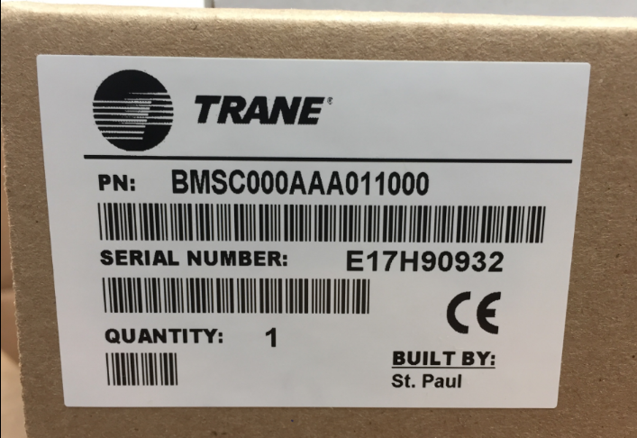

In the software, you will click “Installation” then “Licensing”

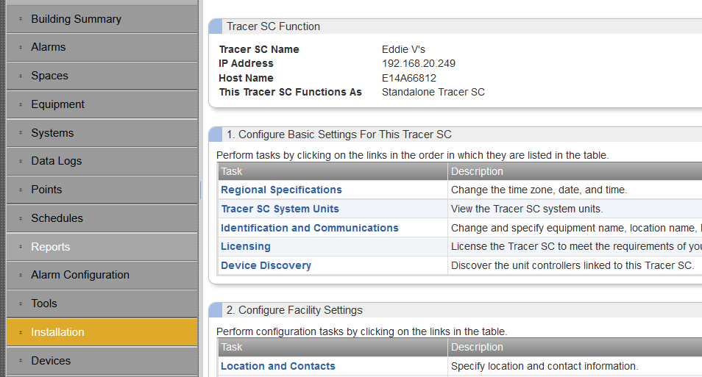

This will take you to a page which shows the Hardware Serial Number as required in the information to be emailed below

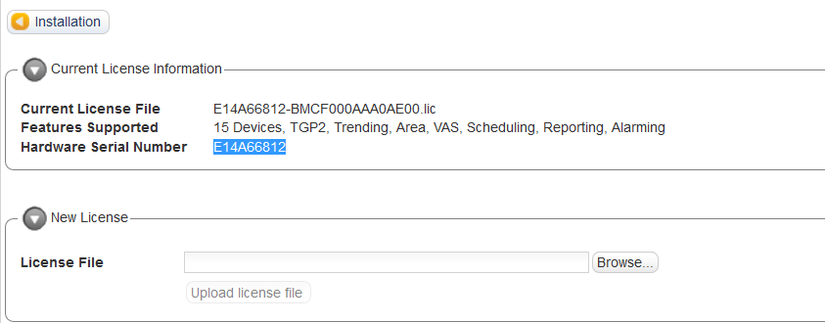

Then retrieve the License File Serial Number from the white envelope which is physically mailed to Nomad

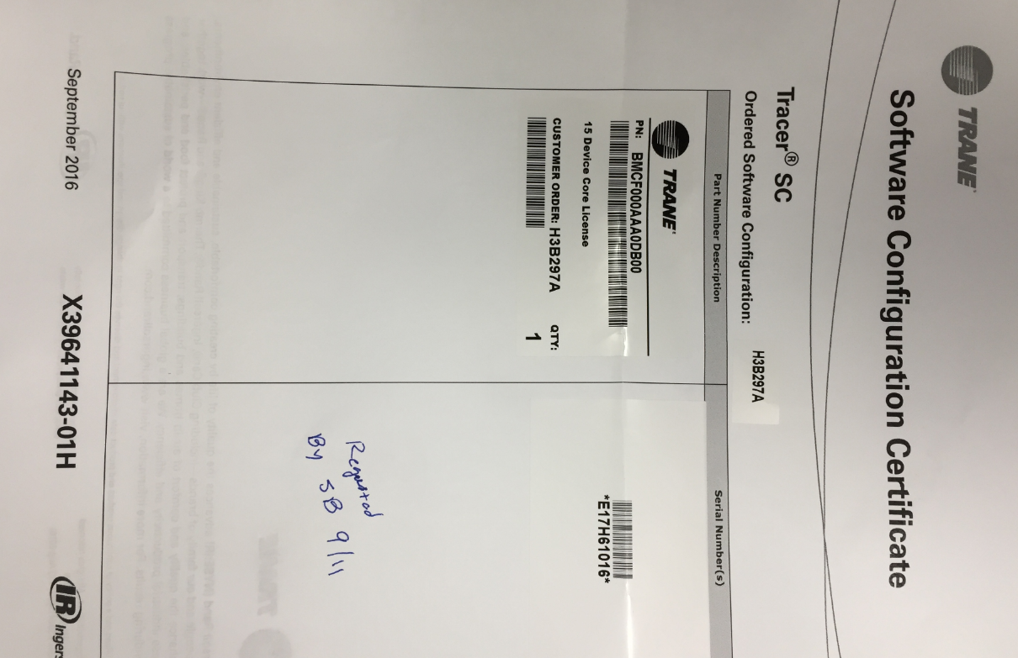

Fill out the below information as shown in an email and send it to Jose Diaz [jdiaz@trane.com](mailto:jdiaz@trane.com)

* + 1. Customer: Nomad Group
    2. Location: LH XXXX
    3. Street Address:
    4. Country: USA
    5. State:
    6. City
    7. Site Contact Person: You
    8. Site Contact Email: [darden@nomadgroup.com](mailto:darden@nomadgroup.com)
    9. SC Serial #: (from device)
    10. License #: (from paper license that Trane sends)

Here is an example of the described email

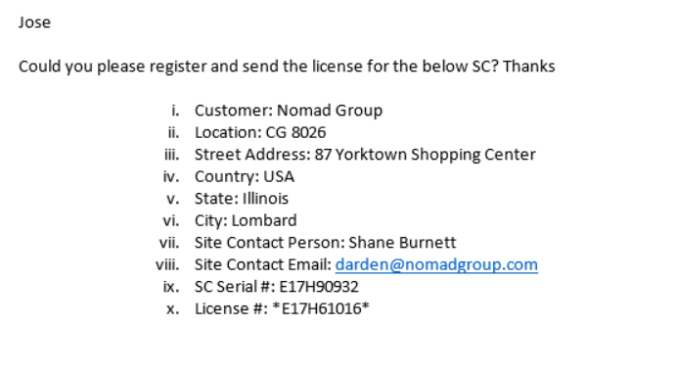

An automated Trane account will then email you a “license file” you will then go back into the Tracer SC web browser access and go to Installation -> Licensing -> Browse for License File then press Upload File.

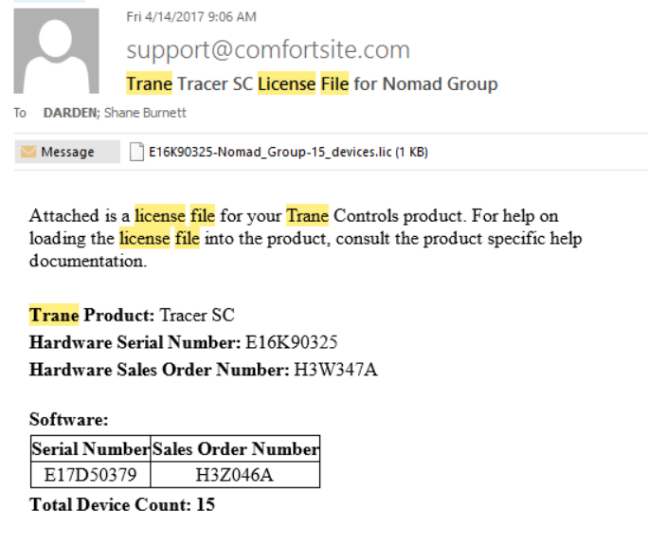

This will then upload the assigned license file from Trane to the specific Tracer SC you are working on.